- Dr. Lena Ecf y ;11(Is -
\
Cl.I. a.LI DO

509 Bramhall Avenue, Jersey City, NJ 07304 Tel. 201-433-5300, Fax 201-433-0935

July, 2018

Greetings Parent(s)/Guardian(s),

We hoped you are enjoying a safe summer. Welcome to our families who are joining our school community this year. For our returning families, we thank you for your continued dedication and support.

Please note some very important information below:

•!• Ice Cream Social - 5:00 pm-7:00 pm
•!• Ice Cream Social - 5:00 pm-7:00 pm
•:• 1 st Day of School

•!• School Start Time
•:• All Students Must be in Full Uniform -
August 27th (Grades: K - 5) August 28 ^{th} (Grades: 6 - 8) Thursday, September 6th
8: 15 am (promptly) Including Black Footwear­ Mandatory

Student Forms Due on Thursday, 9/6/18:

•!• Emergency Contact/Medical Form, Student
•!• Emergency Information Card (front and back)
•!• Universal Child Health Record
•!• Photo Release Form
•:• Home Language Survey Form
•!• Student Housing Survey Form
•!• Sports Physical form
•!• Parent/Guardian Permission Form

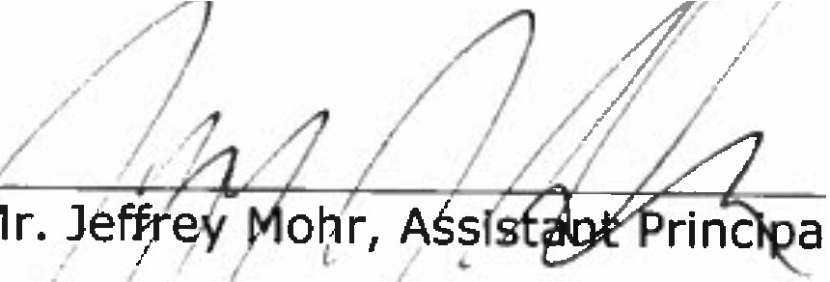
If you have any questions, please contact us at 201-433-5300. Sincerely,
7
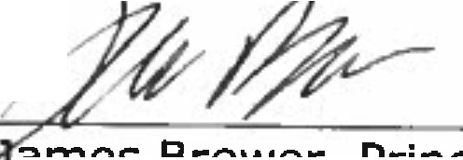L
- -
Mr ?la m es Brewer, Principal al

I

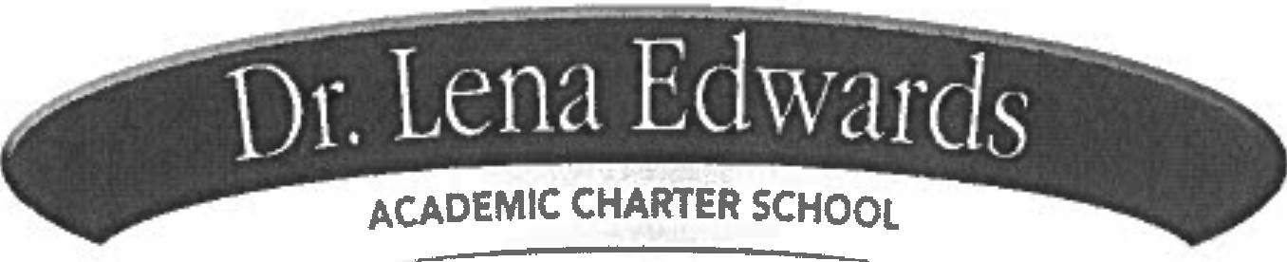

To: All Returning Families, July 2018

Dr. Lena Edwards Academic Charter School is currently accepting Registration Applications for 2018-2019 for Grades K-8.
Many of you have family members, friends and neighbors who would love to have an opportunity to attend our school. Please feel free to give the attached application to a perspective student.
Any questions, please contact the school office at 201-433-5300 ext. 142

Thank you, Ms. Slack
Intake Coordinator

;)-

.. ·· bl·. Cc11it tdwards
Cir.I. .al:J 00

Address: 509 Bramhall Avenue, Jersey City, NJ 07304.Phone: 201.433.5300

Application Instructions

Where Do I Get An Application?
Applications for Admission are available in English, Spanish and French and can be downloaded on school's website at: www.drlenaedwardscharterschool.org
Applications can also be obtained from Or. Lena Edwards Academic Charter School, 509 Bramhall Ave., Jersey City 07304.

Where to Submit Applications; Who May Submit an Application;
Applications can be submitted to: Dr. Lena Edwards Academic Charter School, 509 Bramhall Ave., Jersey City 07304. Attn: Admissions Dept. Applications can be hand delivered to the same address. Applications can be submitted on line at: www.drl ena edwardscha rt erschoo l.org

Applications from the previous year cannot be carried over beyond the school year applied for.

Jersey City Residents; Non-Residents;
Jersey City residents and non-residents may apply to OLEACS. Jersey City residents will receive preference.

Kindergarten Cut Off;
Kindergarten applicants for 2018-2019 will only be valid if your child will turn five on or before October 1, 2018. Kindergarten applicants with siblings enrolled in DLEACS are exempt from the lottery.

Application Deadline;

Applications must be received on or before 5:00 pm Thursday, April 16, 2018. Lottery Date;
Lottery Date is scheduled for Thursday, May 3, 2018. The lottery drawing will be held at Dr. Lena Edwards Academic Charter School at 6:00 pm in the school cafeteria, 509 Bramhall Ave., Jersey City, 07304. (your presence Is optional).

•<J
- I
. ,. l> il ! (.•

REF#

Charter Schools are free, open-enrollment public schools that are required by law to serve all students. Charter schools shall be open to all students on a space available basis and shall not discriminate in their admission policies or practices on the basis of intellectual or athletic ability, measures of achievement or aplitude, special needs, proficiency in the English language, or any other basis that wo11ld be illegal if 11sed by a school district.
DR. LENA EDWARDS ACADEMIC CHARTER SCHOOL
2018-2019

Student's Name-----------------------------
(Last) (First) (Middle)

Gender_ _
_ _ Age Date of Birth /
--/

What grade is student applying for in the 2018-2019 school year? _

Addrass _ _ _ _ _ _ _ _ _ _ _ _ _ _ _ _ _ _ _ _ _ _ _ _ _ _ _ _ _ _ _ _ _ _ _ _ _ _ _ _ _ _ _ _ _
(Number/Name ofStreet) (Apt.#} (City/State} (ZipCode)

Mailing Address - - - - - - - - - - - - - - - - - - - - - - - - - - - - - - - - - - - - - - - - - - -
(if different from above) (P.O. Box# or Number/Name of Street} (City/State) (Zip Code)

Home Phone#----------

FAMILY INFORMATlON

Check one: _ Parent _ Step-parent_Legal Guardian Full Name: _ Home Phone: _
Work Phone: _ Cell Phone : _ Email Address: _

Alternate Phone# _

Check one· _Parent _Step-parent _Legal Guardran Full Name: _ Home Phone: _
Work Phone:----------- Cell Phone: _

Email Address: _

Sibling Policy : Preference ls given to slblings of enrolled students (N J S.A 36A-8c). Please list any siblings(brothers/sisters)
applying for or enrolled at Dr. Lena Edwards Academic Charter School this year

Sibling 1 Name _

Sibling2 Name Sibling3Name
Grade in 2018-2019 _ Grade in2018-2019 _ Grade in2018-2019
(

Dr. Len;1 EdWi1i:Js--·--
ACAOEMIC CHARTER S-C--HOOL

COM PASSION• DI LUG.ENCE• INTEGRITY· RESPECT· RESPONSIBILITY
509 Bramhall Ave. Jersey City. NJ 07304:201-433-5300

LETTER TO PARENT REGARDING ADMINI STRATION OF MEDICATION IN SCHOOL

Dear Parent,

In case you are unfamiliar with the school's policy on the administration of medication to students by the school nurse, we would like to bring you up to date on this matter. If your child must have medication of any type during school hours, including over-the counter drugs, you have the following choices:

  - You may come to school and give the medication to your child at the appropriate times.
  - All medicines brought to school must be in the original container.
  - All prescription medicines must have a pharmacy label.
  - No medicine can be accepted by the school nurse without a doctor's order and parent pennission.
  - Any medicine (prescription or over-the counter) to be given by the school nurse must
have a written order from the doctor and parent/guardian permission.
  - All medicines to be given by the school nurse must be brought to school by
parent/guardian and picked up when medicine expires or end-of-school year.
  - If your child is subject to unusual health haz.ards such as allergy to certain foods or bee stings, and/or requires special medical intervention. (eg. asthma, diabetes, etc.) Please notify the school nurse.
  - Diabetic students: The School Staff will follow the New Jersey State Board of Education Plan for "Care of Diabetic Students at School." Contact the school nurse for development of your child's Individual Health Plan.
  - Some students may need self-medication for certain chronic health conditions. Students who need to self-medicate with prescription drug (i.e. inhaler, Epi-pen, oral prescription medications. etc.) must have a self-medication authorization form on file at school, which includes the physician and parent/legal guardian signatures. Forms are available in the nurse's office.
  - At the conclusion of a student's treatment, the unused medication must be removed from the school by the parent.

School personnel will not administer any medication to students unless they have received a medication form properly completed and signed by the doctor; and the medication has been received in an appropriately labeled container. In fairness to those giving medication and to protect the safety of your child, there will be no exception to this policy. If you have any questions about this policy, or other issues related to the administration of medication in the schools, please contact School Nurse. Thank you for your cooperation.

5

C orn f"""'ion I n : ty pe,:;t P .e< l:<Ui.'Y
509 Bramhall Avenue, Jersey City, NJ 07304.Phone: 201.433.S300

Dear Parents/Guardians,

At Dr. Lena Edwards Charter School we work hard to ensure that students' minds and bodies are ready for learning each day. In addition to the hard work our teachers and staff do every day to prepare students for success in the classroom, we can a]so work to encourage hea]thy eating and physica1 activity, leading them to lifelong success. By helping them start healthy habits early in life, we can help reduce our children's' health risks and increase their chances for longer, more productive lives.

Parents/guardians should:

- Honor their child's birthday by sending non-food treats such as stickers or pencils
- Ensure all food sent to school for birthday celebrations promote healthy food choices (see the list of healthy snack ideas attached to this letter).
- Ask your child's teacher what non-food or healthy rewards/incentives they are utilizing in the classroom.
- Become involved in planning school holiday parties that include games, crafts and healthy foods and beverages.
- Participate in brainstonning ideas for healthy, non-food focused fundraisers for the school.

To encourage your participation in this plan, attached to this letter you will find suggested food and beverages. These items are consistent with the intent of the district's Local School Wellness Policy and will promote healthful eating among our students. Also note that students will not be allowed to bring in junk food items such as chips, candy, drinks, etc. to school.

In addition we are no longer allowing homemade or home-baked food items to be served to students .All foods and snacks provided to students as a shared snack during school hours must be store bought and display an ingredient label for food allergen verification.

As educators, caregivers and loved ones we all want the best for our students. Thank you for joining us in giving students healthy opportunities to celebrate important events and achievements.

If you have any questions, please contact the school. We are looking forward to making our school the healthiest it can be so our students can do their best work.

Have a healthy day!

Sincerely,

Nurse Garcia

t,

Our goal is not to cut out all treats, but to make sure they are eaten in moderation and do not become the focus of parties or celebrations. The focus should be on fun, not food. The list below provides nut free healthy suggestions for celebrations. This list is only to serve as a resource. PLEASE READ THE LABLES each time you purchase. Some food items may be subject to manufacturer recalls and mislabeling. Manufacturer may have changed their equipment or product line and method since you last purchased an item from this list. Do not purchase items with the allergy and ingredient alert such as: "May Contain Peanut or Tree Nuts" Processed on shared equipment with Peanuts or Tree Nuts" Manufactured in a plant with Peanut or Tree Nuts" Contains Peanut or Tree Nut Ingredients'. Thank you for taking the time to read the labels and discussing the topic of "safe snacks" with your child! Your diligence is keeping an allergic child safe in school.

Healthier Options

100%juice instead of punch, Pouch or box (Juicy Juice, Apples and Eve, Honest Kids, Brands)
- 100% fruit juice freezer pops (fruit bars, Whole fruit Fruttare, Chloe's, Welsh Outshine, Lifeway Brands.
Fresh Fruits
- Vegetable tray with low-fat dip (Kraft. T'Marzetti's Hidden Valley Ranch veggie dip)
- Plain Popcorn (light or low-fat popcorn) Dried fruit (no sugar or low sugar)
Fruit cups in water (Dole)
Graham crackers (Nabisco, Honey maid, Kroger,
Meijer,)
- Nutrigrain Cereal or yogurt bars (Kellogg's Brand)
Raisins (Plain not yogurt or chocolate covered)
Low.fat yogurt cups or tubes
I 00% Fruit leather/fruit roll ups (Kroger, Nabisco)
- Sparkling water
- Low fat pretzel (UTZ, Rold Gold, Syferts)
- Low fat pudding cups (Kroger, Jcll-0, Hunts,
Kraft)
- Whole grain tortilla chips (Frito Lay, Better made, Sun chips, Fritos Brands)
Whole grain crackers reduced fatffriscuits, Wheat Thins (plain)
- Reduced fat cheese (Sargento or Meijer)
- Little bites muffins pouch (Entenmann's)

We encourage parents to use the list above as a guide in providing healthy snacks. You may also choose to bring in non-food items to give to each child on your child's birthday. Here is a list of ideas: Please keep in mind that all goody bag Items must be age- appropriate. Non- Food Goody bag ideas!

Slap bracelets Silty bands Stickers

  - Crazy straws Mini flashlights
.• Note pads
.
.

- Markers
- Key chains
Coloring books Stamps

Book mark • Plastic ring
- Beach ball • Erasers
- Rings • Crayons
.

- Stencils
- Silty sunglasses
- Pens
Decorative pencils

Here arc a few other ways that you can celebrate your child's birthday at school:
- Donate a book to the school in honor of your child's birthday with his/her name inside.
- Have your child bring their favorite book to share and read it to the class.
- Choose a favorite song or musical piece to sing or play for the class.
Whether your child eats his or her snack at home or at school, or if you provide a snack for a classroom party or celebration, keep these things in mind:
- Snacks should be kid-size. Both children and adults don't need large portions. Snacks should be colorful. Kids eat with their eyes. Make snacks visually appealing.
- Snacks should be healthy. Offer fruits and vegetables as often as you can.
- Drinks should be served in small portions, a cup or less each. Water is the healthiest choice.

1

UNIVERSAL

CHILD HEALTH RECORD
Endorsed by American Academy of PediatnC$, New Jersey Chapter New Jersey .Academy of Family Physicians
New JfJl'Sey Department of Health

.. , ,, -. ,_.:. .- : / !' ;;;,;SEC I:.·roBE.COMPLEITED BYP.ARENT(SJ .- .I . .
Child' s Name (Last) |  | (F1tsl) Gender Date of 8ilth
Does Child Have Healtti Insurance?  0Yes 0No |  | ff Yes. Name of Child's Health Insurance Carner
ParenVGuardian Name |  |  |  |  | Home Telephone Number |  |  |  |  | or1t Telephone/Cell Phone Number
Parent/Guardian Name |  |  |  |  | Home Telephone Number |  |  |  |  | or1t Telephone/Ceo Phone Number
I give my ,:onsent for my child'• Health Care Provider •nd ChHd Cara Provider/School NurH to discuss the lnfomration on this form.
Signature/Date |  | This form may be released to WlC.  0Yes ONo
SECTION°II - TO BE COMPLETED SY HEALTH CARE PROVIDER
Date of Physical Examination: |  |  |  | J Results of physical examination normal? Oves |  |  |  |  |  |  |  | ONo
Abnormalities Noted: |  |  |  |  |  |  |  |  | Weight (must b& raken .'  within 30 days for wrCJ .
Height (must be taken I
Within 30 days for WICJ
Head C1rC\Jmference
(if <2 Years}
Blood ?ressUl'e
(if ::.3 Years)
IMMUNIZATIONS |  |  | 0 Immunization ReCOtd Attached  0 Date Next Immu nization Due:
MEDICAL CONDITIONS
Chronic Medical Conditions/Related SU<genes  - List medical conditions/ongoing surgical  concerns; |  |  | [:::J None  0 Special Cate Plan  Attaci'\ed |  |  |  | Comments
Medication$1Tre.atments  - Li$t medicationsl!reatments: |  |  | [:!None  0 Special C.ire Plan  A!lached |  |  |  | Comments
Limitations to Physical Activity  - List limitations/special consiclerat ions: |  |  | LJNone  0 Special Care Plan  Attached |  |  |  | Comments
Special Equipment Needs  - list items necessary for daily actillities |  |  | l..J None  0 Special Care Plan  Attached |  |  |  | Comments
Allergiei;/Sensitivitles  - Lisi allergies: |  |  | ONone  D Speoal Care Plan  Attached |  |  |  | Comments
Special DieWitamin & Mineral Supplemenls  - List dietary specifications: |  |  | 1...J None  D Soecial Care Pran  Attached |  |  |  | Comments
BehaV1on1I Issues/Mental Health Diagnosis  - List behavloral/mental health Issues/concerns. |  |  | 0None  0 Special care Plan Attached |  |  |  | Comments
Emergency Plan&  - List emergency plan that might be needed and the sianlsvmotoms to watch for: |  |  | U Neroe  0 Special Care Plan  Attached |  |  |  | Comments
PREVENTIVE HEALTH SCREENINGS
lYOe SCrHning |  | Date Perfonned |  | Reeonf\l'ah.ie |  |  |  | TY1)9 Screening |  | Datt Perfom,ed |  | Note if Abnormal
Hgb/Hct |  |  |  |  |  |  |  | Hearing
lead: 0 | Capillary O Venous |  |  |  |  |  |  | Vislon
TB (mm of lndur;itton) |  |  |  |  |  |  |  | Dental
Other: |  |  |  |  |  |  |  | Developmental
Other; |  |  |  |  |  |  |  | Scoliosis
D I flave tKamlned the above atudent and reviewed hl-'her health history. It Is my opinion that he/she is medically cleared ro
partielpatt fully In all chlld c11relschool 1tetlvftf11s, including phyflcal education and competitive contact sports, unless not«/ above.
Name of Health Care Provider (Print) |  |  |  |  |  | " l · ·· 1,.:.,.t;' f;·1.,·..1,;c. ."t i m, t.·
SignatureJOate

I OMale D Female I I

I

CH-1 JUL 12 OistribuUon. Onginal-Chlkl Care Provider Copy-Parenl/Guaroian Copy-Health Care Provider

y

Instructions for Completing the Universal Child Health Record (CH.14)

Section 1 - Parent
Please have the parentrguardian complete the top section and sign the consent for the cllild care provider/school nurse to discuss any information on this form with the heanh care provider.
The WIC box needs to be checked only if this form is bemg sent to the WIC office. WIC is a supplemental nutrition program for Women , Infants and Children that provides
nutritious foods, nutrition counseling. health care referrals and breast feeding support to Income eligible families. For more information about VVIC in your area call 1-800-328-3838.
Section 2 - Health Care Provider
- Please enter the t of_the physical exam that is being used to complete tM foml. Note significant abnormalities especially ,f the child needs treatment for that abnormality (e.g. creams for eczema; asthma medications for wheezing etc.)
  - Weight - Please note pounds vs. kilograms. If the form is being used for WIC. the weight must have been taken within the last 30 days .
  - Height - Please note inches 11$. centimeters. If the fonn is being used for WIC, the height must have been taken within the last 30 days.
  - Head Circumference - Only enter if the child Is Jess than 2 yeara.
  - Blood Pressure - Only enter rf the child is 3 years
or o lder.
- Immunization - A copy of an immunization record may be copied and attached. If you need a blank Form on which to enter the immunization dates, you can request a supply of Personal Immunization Record (IMM-9) cards
from the New Jersey Department of Health. Vaccine Preventable Diseases Program at 609-826-4860
  - The Immunization record must be attached for the fom, to be valid.
  - "Date next immuniZation is du·e is optional but helps child care providers to assure that children in their care are up-to-date with immuniZations.
- Medical Conditions - Please list any ongoing medical condibons that might impact the child's health and well being In the child care or school setting.
- Note any significant medical conditions or major surgical history. If the child has a complex medical condition, a special care plan should be completed and attached for any of the medical issue blocks that follow. A generic care plan (CH-15) can be downloaded at www.nj.gov/heafthlforms/ch-15.dot or pdf. Hard copies of the CH-15 can be requested from the Division of Family Health Services at 609-292-5666.
- Medications • List any ongoing medications. Include any medications given at home if they might impact the child's health while In child care (seizure. cardiac or asthma medications, etc.). Short-lenn medications such as antibiotics do not need to be lrsted on this form. Long-term antibiotics such as antibiotics for urinary tract infeetions or sickle cell prophylaxis should be included.
PRN Medications are medications given only as needed and should have guidelines as to specific factors that should trigger medication administration.

;. - · .::; ; ,r. J:tnlC :t v :. _:
,.,)I. I.'

Please be specific about what over-Iha-counter (OTC) medications you recommend, and include information for rhe parent and child care provider as to dosage, route, frequency, and possible side effects. Many child care providers may require separate perrmss10ns sffps for prescription and OTC medications.
- Limitations to physical activity - Please be as specific as possible and include dates of limitation as appropriate. Any limitation to field trips should be noted. Note any special considerations such as avoiding sun exposure or exposure to allergens. Potential severe reaction to insect stings should be noted. Special conS1derations such as back-only
sleeping for infants should be noted.
d Speclaf Equipment - Enter if the child wears glasses, orthOdontic devices. orthobcs. or other special equipment Children with complex equipment needs should have a care plan.
- Allergles/Sensltlvities Children with life­ threatening allergies should have a special care plan. Severe allergic reactions to animals or foods (wheezing etc.) should be noted. Pediatnc asthma action plans can be obtained from The Pediatric Asthma Coalition of New Jersey at www.pacnj.org or by phone at 908-687-9340.
- Special Olets - Any special diet and/or supplements that are medically indicated should be included. Exclusive breastfeeding should be noted.
- Behavioral/Mental Health issues - Please note any sigmflcant behavioral problems or mental health diagnoses such as autism. breath holding. or ADHD.
- Emergency Plans - May require a special care plan if interventions are complex. Be specific about signs and symptoms to watch for. Use simple language and avoid the use of complex medical terms.
- Screening - This section is required for school. WIC, Head Start, child care settings. and some other programs This section can provide valuable data for public heath personnel to track children's health. Please enter the date that the test was performed. Note if the test was abnormal or place an "'N" if it was normal.
  - For lead screening state if the blood sample was capillary or venous and the value of the test performed.
  - For PPD enter miRimeters of induration, and the date listed should be the date read. If a chest x-ray was done, record results.
  - Scoliosis screenings are done biennially in the public schools beginning at age 10.
This form may be used for clearance for sports or physical education As such. please check the box above the signature line and make any appropriate notations fn the Limitation to Physical Activities block.
- Please sign and date the form with the date the form was
completed (note the date of the exam. if different)
  - Print the health care provider"s name.
  - Stamp with health care site's name. address and phone number.

_ ...,':\.

q

STUDENT INFORMATION/EMERGENCY 2018- 2019

Student's Name,
(Las! Name) (Fir11t Name)

Grade (2018·19) _

Addres_s _ _ _ _ _
_ _ _ _ _ _ _
_ _ _ _
_ _ _
_ _ _ _
_ _ _
_ _ _
Binhdalc ;
/_ _

Paren!IGuardian Name # l: HorneAddr ess_ : _ _ _ _ _ _ _ _ _ _ _ _ _ _ _ _ _ _ _ _  Home Phone:_ _ _ _ _ _ _ _ _ _ _ _ _ _ _ _ _ _ _ _  CellPhone_ : _ _ _ _ _ _ _ _ _ _ _ _ _ _ _ _ _ _ _ | ParcnvGuardian Name 1/2: _ _ _ _ _ _ _ _ _ _ _ _ _ _ _  Home Address: Home Phone:_ _ _ _ _ _ _ _ _ _ _ _ _ _ _ _ _ _ _ _ CellPhone_ : _ _ _ _ _ _ _ _ _ _ _ _ _ _ _ _ _ _
WorkPhone_: _ _ _ _ _ _ _ _ _ _ _ _ _ _ _ _ _ _ | Work Phon_e:_ _ _ _ _ _ _ _ _ _ _ _ _ _ _ _ _ _ _
Preferred Email: _ _ _ _ _ _ _ _ _ _ _ _ _ _ _ _ _ _ _ _  Emp ol yer_ : _ _ _ _ _ _ _ _ _ _ _ _ _ _ _ _ _ _ _ | Preferred Ema_i:l _ _ _ _ _ _ _ _ _ _ _ _ _ _ _ _ _  Employer:
Job Title : | Job Title:

Custody
Custody of st udent is with:
Both Parents/Guardians - Joint
, Mother/Guardian - Only
Reside11cy
Student resides "ith (please check one 011ly).
Both Parents/Guardians· Full Time Both Parents/Guardians • Shared Time

Father/Guardian - Only Mo!her!Guardian - Only
Other {P leas e explain below) Father/Guardian - Only
Other (Please exp lain below}
SPECIAL CJRCUMST ANCES:
(Please describe any special circumstances regarding custody or r s1dency 1ha1 exist A:tach any documen1s desetibmg custodial ngh1s ,u rew ic11o ns ;

AIH'LTS AUTHORIZED TO PICK UP MY CHILD: I give pcnnission lbr my child to be rclca. cd from HoLa and the atkrcare and enrichment programs to adult listed bclO\\ and for these ind ividuals to a5.,um c rcspon$ibili!y for my child In ca!'e of an emergency iflhc custodial parents cannot be reached .

NAME PHONE# RELATIONSHIP TO CHII. D
1 ------------------- ---------,-,----,- -- -------,,--,,------,----,-,---,-
NAME PHO'.'vE /I REI.AT1ON HIP TO CHILD
E ll-f ERGENCY CONTACTS (if parcntsigunrd,ans can not w reached ):

NAME PHO NE /I RELAT1O:'-SHII' TO CHILD

NAME l'HO;',E # RELAT IO:'<S UIP TO CHILD
In ca!'C of An acclclcnt or :i.crious illness. I ask that the sthoot conhlcl lhc parent on 1hls form. H lhc sthool ls unMblc to reach a p11rcnl. I aulhori:7.c the school lo contact the emergency conlacl !bled ab<)V(!, Ir the physician is not nvailable. th school may arnngc care as nced..-d.
Recurring lllnc,;s

Cl
Commcnb:
Allef'lliell AMhm:1 Dtabelt>S Epikpsy
Henri Probkm.•
0
0
0
0
0
MEDICAL JNFORi\lATION
Physicians Namc-:--,---,-----------------­ Physicians Phone
Exi,ting Meditatl Condilions:
••()ocumcntathm vcrifyinl! •pedal clrcum tanc aho,·c mu t be pru'l'idcd prior to tudcnt 11Ucndancc. If any of the ,.t,ovc information chan;cs. it Is the pannu'
rcsponsibillty lo notify the 5chool.••
Parent/Guardian #J Signature: _ Date : ,

Parent/Guardian #.2 Signature: _ Date :

,v

Dr. L J1g._Ed r rds
- ...,-4 -- '
CI.LADtM11.. 1..nARTER :5CHOa

i::.li

12 CHAPEL AVENUE, JERSEY CITY, NEW JERSEY 07304, 201-433-5300

CONSENT AND RELEASE
FOR PHOTOGRAPHS, PRESS AND/OR WEBSITE

As a parent/Guardian, I authorize taking pictures/videos of my child for use in newspaper and magazine articles, internal public relations projects, television broadcast and/or the school web site as approved by Dr. Lena Edwards Academic Charter School. The consent is intended to release from liability the use of such pictures for Dr. Lena Edwards Academic Charter School and everyone publishing them with its permission. I agree to hold harmless and indemnify the school and its agents and employees against any and all claims for harm to my child involving said pictures.

PARTA

SIGNING THIS FORM GRANTS PARENTAL PERMISSION TO DR. LENA EDWARDS ACADEMIC CHARTER SCHOOL FOF THE DURATION OF THE TIME THE CHILD IS ENROLLED IN THE SCHOOL.REMOVAL OF PERMISSION IS THE SOLE RESPONSBILITY OF THE PARENT/GUARDIAN AND MUST BE DONE IN WRITING WITH AN EFFECTIVE DATE.

(Print Student's name) Grade

(Print Parent/Guardian Name

Signature of Parent/Guardian Date

PARTB

I DO NOT AUTHORIZE THE TAKING OF PICTURES OF MY CHILD FOR ANY REASON.

(Print Student's name) Grade

(Print Parent/Guardian Name
,t
Signature of Parent/Guardi n n-•-

Dr. Lena Ed\\ra-rds ---
o.<-ADEMI M,'\fHER :> HOCJ

509 BRAMHALL AVENUE. JERSEY CITY, NEW JERSEY 07304, (201) 433-5300 FAX: (201) 433-0935

PARENTAL/GUARDIAN PERMISSION 2018-2019

I hereby grant permission for: my student to leave school grounds with staff members for neighborhood walks and community field trips.
Trips outside of Jersey City or trips using private bus lines will be handled by separate permission forms.

student's
Name:----------------

Grade: _ Print Parent/Guardian Name

Parent/Guardian Signature

Date

I z,

Home Language Survey

ESL File Opened  D Yes D r-b | ESL Test Date | Today's Dale |  | Test
ESL Evaluator |  |  | ESL Level |  | Placement
PARENT/GUARDIAN HOME LANGUAGE SURVEY
Student's Name Grade

Relationship of Person Completing Survey
D Mother D Father D Guardian D Other Specify
Directions:Check the correct response for each of the following questions and indicate other languagesif appropriate
English Other Other Language(s)

the school to be in English?
0 Oral D Written
If no, in what language
1. What language did the child learn when she or he first began to talk? | D | D
2. What language does the family speak at home most of the time? | D | D
3. What language does the parent(s) speak to her/his child most of the time? | 0 | 0
4. What language does the child speak to her/his parent(s) most of the time? | D | D
5. What language does the child hear and understand in the home? | D | D
6. What language does the child speak to her/his brothers/sisters most of the time? | D | D
7. Whal language does the child speak to her/his friends most of the lime? | D | 0
 | Yes | No
8. can an adult family member or extended family member speak Engl sh? | D | 0
Can they read English? | D | 0
9. Do the parents/guardians request oral and/or written communication from | D | 0

SIGNATURE
Signature of Person Completing Survey
Date Signed

tJ

Dr. Lena Edwards Academic Charter School I 2018-2019 CALENDAR

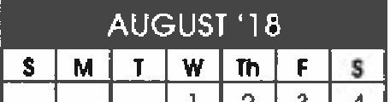27-31 Classroom Set-up
I L. ,J .. I
31
30
29
28
27
26
25
24
23
22
21
20
19
17
16
15
14
13
12
11
18
10
9
8
7
6
5

28-29 New Hire Orientation
7 • Report Cords Dist.
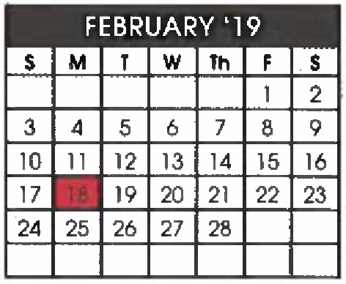
- - Presidents· Day­ No School

- days

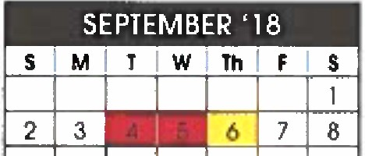
3 - Lobor Doy- No School MARCH '19 t - Progress Reports Dist.
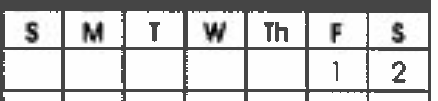
4-5 - Stott In Service-
No Schoo l for students
6 - School opens - all students report
3 | 4 | 5 | 6 | 7 | 8 | 9
10 | 11 | 12 | 13 | 14 | 15 | 16
17 | 18 | 19 | 20 | 21 | 22 | 23
24 | 25 | 26 | 27 | 28 | 29 | 30
31 |  |  |  |  |  |  | I | 21 Days

20 - Bock-to -School Night· 6-8 pm
9 | 10 | 11 | 12 | 13 | 14 | 15
16 | 17 | 18 | 19 | 20 | 21 | 22
23 | 24 | 25 | 26 | 27 | 28 | 29
30

24 - NDI Re sid enc y Begins - Grodes4&5

17 days

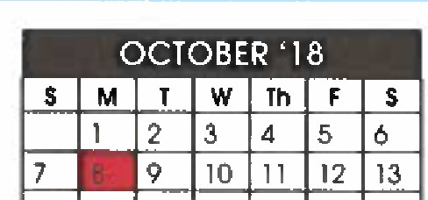4 Progress Reports Dist.

14 15 16 1 7 18 19 20
21 22 23 24 25 26 27
28 29 30 31 I
I
I = r,sl,!ffl 8 PAACC Window Opens
8 Columbus Doy - 12 End of, 30 M.P

No School I

1 A C L
- Half Day
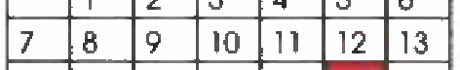
- Good Friday- No School
22-26 Spring Break

22 days
! 1 14 1 1s 1 16 1 17 1 a1
20 I
29 - School Resumes

I I I I I I I I 16 Days

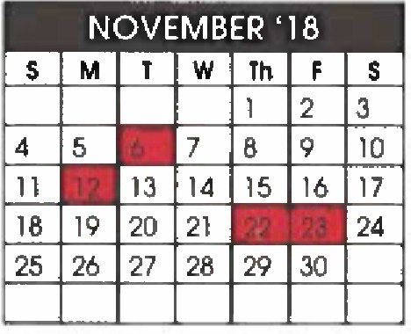
6 Elec tio n Doy No School 6 - Sc ienc e Assessment
8 End of 1•' M.P. Window Open- Grs 4 & 8
12 · Veterons Doy - No Scho o l 15 - Progress Reports Dist
 |  |  |  |  |  | 4
5 | 6 | 7 |  | 9 | 10 | ll
12 | 13 | 14 | 15 | 16 | 17 | 18
19 | 20 | 21 | 22 | 23 | 24 | 25
 |  | 28 | 29 | 30 | 31

15 · Re port Cords 1-8pm 12 45 Dismissal
21 - Half day - 12:45
22-23 Th a n ksgiving Break • No Sc h oo l
- - M em oria l Doy- No School
- PAACC Window Closes

19 Days 22 days l

10 · NDI Perfo rm a nc e - Grodes4& 5
S I M I T I W I Th l F I S

2 3 4 5 6 7
9 | 10 11 | 12 | 13 | 14
 | 17 18 | 19 | 20 | 2l | 29

7 . Science Assessml)nl Window l
Closes
2 | 3 | 4 | 5 | 6 | 7 | 8
9 | 10 | 11 | 12 | 13 | 14 | 15
16 | 17 | 18 | 19 | 20 | 21 | 22
23 | 24 | 25 | 26 | 27 | 28 | 29

26 - Last Day of Sch ool (0 8mergency

14 - Progress Reports Dist . days used)
21 - Half day II emergency days ore used, odd clays
lrom the 26"'.

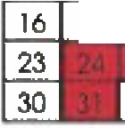24-31 Christmas Break
150ays 30

losl 3 doys of school ore 12:45 dismissal s.

18doys
I
190totol doys.

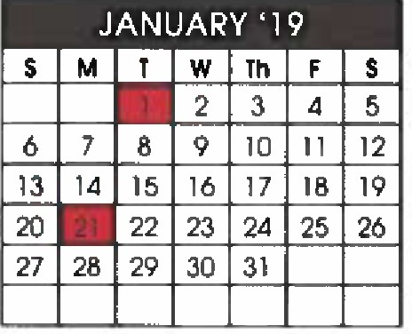
1 - New Year's Day - Every Friday 1s o 12:45 Kindergarten and Grode 8 No School Dismissal. graduation dotes are TBD.
2- School Resumes I

21 - M.L King, Jr. Day -
All half days are o 12 :45
I

No School dismissal for students
28 - End of 2r\d M .P.
I
21 Days I
I

Sc/Joo! Calendar Template@calenciorlobs.com l"'

KIDSTOWM
Great selection. Great prices.

Dr. Lena Edwards Academic Charter School
509 Bramhall Avenue Jersey City, NJ 07304 201'-433-5300

Dear Parents,
We are happy to announce exciting news about our continuous partnership with Kidstown,
as our "Official Supplier for School Uniforms" for the upcoming school year.

We believe that shopping for school uniforms should be easy, affordable and enjoyable, and that is why we have selected Kidstown as our neighborhood location to visit. They are conveniendy located in the Jersey Gardens Mall, are family owned, and are generously offering the following programs to our school community.

- l 0% off school uniforms all year long
- Shop to Earn Program
- Everyday low prices
- 20% off school uniforms in the month of July
- Lay-A-Way Program
- Large inventory selection all year long

Please find our dress code and prices on the reverse side of this letter.

Queridos Padres,
Nos complace anundarles que estaremos continuando nuestra asodacion con Kidstown nuestro proveedor de uniformes escolares para el proximo ano escolar.

Nosotros creemos que comprar uniformes debe ser fadl y asequible es por eso que hemos se/ecdonado Kidstown. E.//os estan convenientemente localizado en Jersey Gardens Mall y nos ofrecen generosamente lo siguiente:

- I0% de descuento en /os uniformes durante todo el ano.
- 20% de descuento en los uniformes durante el mes de Julio.
- Gran lnventario de seleccion durante todo el ano
- Programa "compre y gane,"
- Programa de Lay-A-Way
- Precios bajos todos los dias.

ncuentre nuestros uniformes y precios en la parte de atras de esta carta.

Kldstown Store Locations:

Bronx Bronx New Jersey
I 00 E. 170th Street/Walton Ave. 991 Southern Blvd. • Jersey Gardens Ma.II - Upper Level,across from the GAP
718-588-2753 718-893-5391 65 I Kapkowski Road , Eliza.beth, NJ 0720 I 908-351-7300 • NJ Turn Exit 13A
Brooklyn
749 Broadway Brooklyn, NY, I 1206 718-782-0003

visit our website at www.Kidstownusa.com t!'

Dr. Lena Edwards Official 2018-2019
School Uniform Checklist
K TOWM
Great selection. Great prices.

  - Prices are subject to change based on Vendors Avalability.

CHECKLIST
ITEM | LOGO | COLORS | GRADE | 4.7 | 8·14 | 16·20/ S·XL
LS Oxford Shirt  Camisa Manga Larga | Embro | Lt. Blue Azul | K-8 | $14.99 | $16.99 | $16.99/ 19.99
SS Oxford Shirt  Camisa Manga Corta | Embro | Lt. Blue Azul | K-8 | $14.99 | $15.99 | $15.99/17.99
Pant  Pantalones |  | Khaki  Caqui | K-8 | $12.99 | $14.99 | $16.99
Cardigan Sweater  Sueter con Botones | Embro | Navy  Azu/Marino | K-8 | $29.99 | $29.99 | $29.99/34.99
Tie |  | Navy  Azul Marino | K-8 | $3.99 | $3.99 | $3.99

D
D D D D

CHECKLIST
ITEM | LOGO | COLORS | GRADE | 4·6X | 7-14 | 16·20/ S·XL
Long Sleeve Polo  Polo Manga Larga |  | Lt. Blue Azul | K-3 | $7.99 | $8.99 | I
Short Sleeve Polo  Polo Manga Corta |  | Lt. Blue Azul | K-3 | $7.99 | $8.99 | I
Jumper Jopa | Embro | Khaki  Caqu/ | K-3 | $14.99 | $14.99 | I
LS Oxford Shirt  Camisa Manga Larga | Embro | Lt. Blue Awl | 4-·B | $14.99 | $16.99 | $16.99/19.99
SS Oxford Shirt  Camisa Manga Corta | Embro | Lt. Blue Azul | 4-·B | $14.99 | $15.99 | $15.99/17.99
Pant  Pantalones |  | Khaki  Caqui | 4--8 | $12.99 | $13.99 | $15.99
Skirt Falda |  | Khaki  Caqui | K-8 | $9.99 | $10.99 | $11.99
Cardigan Sweater  Sueter con Botones | Embro | Navy  Aw/Marino | K-8 | $24.99 | $29.99 | $29.99/34.99
Ties (Criss-Cross) |  | Navy  Azul Marino | K-8 | $3.99 | $3.99 | $).99

D D D D D
D D D D

CHECKLIST
ITEM | LOGO | COLORS | GRADE | 4-7 | 8·14 | 16-20/ S·XL
Gym Jog Pant  Pantalones de Gymnasia | Decal | Navy  Azu/Marino | K-8 | $10.99 | $10.99 | $10.99/12.99
Gym T shirt  Gvmnasla T shirt | Decal | White  Blanco | K-8 | $5.99 | $5.99 | $6.99
Gym Sweat Shirt Suete de Gvmnl:!siat | Decal | Navy  AzulMi:!rino | K·8 | $10.99 | $10.99 | $10.99/12.99

D D D

BOYS

GIRLS

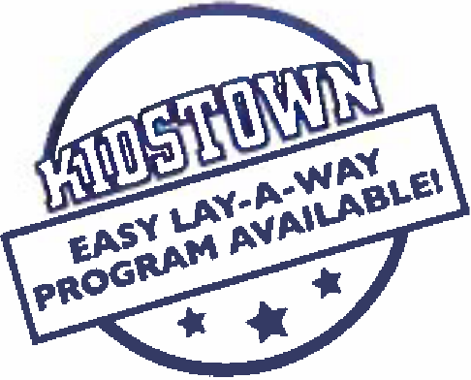
GYM WEAR -

visit our website at www.Kidstownusa.com
'"

!ill P RE P A R T ! C l P A T l O N PHYSICAL E VAL.U A T !O N
THE ATHLETE WITH SPECIAL NEEDS: SUPPLEMENTAL HISTORY FORM
Date of Exam -------------------------------------
Name --- - -·-- - - - - - - - - - - - - - - - - - - - - - - - - - - - - - - - - - Oate ot b11•,r,

Sex
Age Grade Sc:iool --------- Sport(s)

1 Type o! dtsabili:y
2. Oata ol<l'Isabiiily
3 . O,,.ssf.ir.a1iv.i 61availablel
. Cause of diSab,ity fbirth. - act NJenl/.'raooll . Olh tj
5 LISI spcr,s JOO are 1ntcre.100 m Di¥1'119
 | Yes | No
6 . C-o YoU rei1u!a,1y use a bracr.. assislive devu. or proslll:11Jc?
7. Do You i.3e a,,y spt(i;il brate or assisl;ve device 1or soot1s?
8. Oil 1"'11 -a-"' l>'lf laS-'leS. p< sssre sorM . o, 'inf Ol/ler s :n proDlems?
9 Do ynu h.1ve a l>eaf1ng w 1 Do you use a llearag au!? !
I 0. De, yeu !lave a Y1SUal impaim,e:,;>
11 Ou r,llJ use ariy s;;cc,a! devices fo, llowef o, l)lao,oe function?
12. 00 y u nave Dutning o.Oiscomforl wrum ur1nal!f1!!?
13. Have you autooomlc d'f$feflexi,J?
1 r..l¥t )'Oil evet !leer dll91l05ell w.th a :-.eat-r!lia (ll'f,)el1,'1ermiJl o, cokl-refatm _{{t:yp(llhel} _{lllr.l)} lness?
15. t>o you Mve musce spastir.l!'f'
16. Oo 1ou ha\'e !ceo,cenl seizures that W,ll(II 0t con ol!ee tir me1:itat:cm? I
Explaln "ye$" 311$wers here

Pteaso lndi0;1te ii ygu have ever llad any ol lllt following.
 | Yt:S | No
AUaoto.)x i,\s\abtl,:Y
X-ray evaiu;!tieo for anar.toa,.ial inslabi1ity
Oc;lac2ted jo1111s 1r.10<e , one)
Easyble!<llng
Enlarged PIWI
He a:t1;s
Os'J!Ol)enia oros
Diff,culty ror,!n)lliflg bc:1vd | I
Dt.fitu l:yClll'lrl)Ding ;,i.ldGe,
Num:i.10SS or ongrin , am,s 01 llands
flumt>neSS or ti ttr,g in I or ftel
\\'"i<lles:; 1n il-'m$ or lldrld:i
in leg:; 0t fet1!
Aerem change in aiorO;nation
eGe/11 cll:lng 10 aD!li:y to walk | I
Splnabllid | I
latex ai1e,gy
EIIJJhln "yes" a here

I hereby stale Iha!, ID Ille bost of m, knowledge, 11'11 answers la Ille al>ove quCSlioM are complete and correet.

51Qne;c-oolatl>l!!1e
-a:!.:11:'o!f)ilefll' ·, - - - - - - - - - - - - - "'- -- - -· .. ...
11

AITTtmON PARENT/GUAROIAH; The preparticipation physiClll examtoa on [page 3) must be completed by a heanh care provider who has completed the Student-Athlete C..rdiac Asses.sment Professional Development Module.
ilf& PREPARTICIP1\TION PHYSICAL E VALUATION
HISTORY FORM
(Note: r,,rs form Is to be fflled out by the patient and parent plfor to seeing the physician. The physician should keef}I copy of this lotmIn the chart.)
Oateoffxam ------------------------------------

Name
Oate ol tnrth _ _ _
_ _ _ _

Sex Age Grade School
Sport(S)

Cl Stir.ging lnsec:s
O Food
0 ?olfens
CJ Yes O No If y s. please identily specific anerg'( oetow.
Do you /lave any allergies O Medicines
Medicines and Allergies: Please list all of the prescrrp on anc1 GVer-tl'ie-counter medicines and supplemer.ts (herbal arnl nutri or.a11 lhal you are currently taking

E:cplaln "Yes" answers below. Clrele qu Uons you don't know the answers lo.
GENERAL QUESTIONS j Yu No
l. as a ooc:or vc.r aonrc o:- res!rn:led your oarttcip;;:;o in s;;or'.s lor i
ir.r reas.Jn? !
2. DG y,w ha"'! ar.y or.going medical concWo,,s? 11 so.p!e SJJ id'ln:f.-t ;I

MEDICAL QUESTIONS Ye.s j lie
- Do r:iu 0<!9!'- wllecz,. or nave drffic:,1r1 b1eal i:ii;i C:Uf!ll!l · ^{I}
I
l
aftet ex:ercise? I
2;, !lave vo11.ver used en ir, .a!•.i or t.l n asmma medicine? I

below. 0 llslhma D ,1.ncmi 0 Di beles D lr.feclions Other: --···
!
i 3. 11.!v ,o •et s;,e l the mg/11 in !I-oil llos rtal? l
  - ! lh re an)'Qno if, your lorn,ly wno o\S ast ma? I .........
  - Were you bom witn<M or a,e -,cu missing a i:!ney. an eie. a1es.1cle I l
1rnates1, Yout s,icon. or any t or or ;m7
!;

- Ha•e y0u eve, had swgery? !
HEART HEALTH QIIESTIDIIS ABDIJT .YDU I Yes No
i . a\'!! YO• e\' J r-2ssed oi;I OI Marl)'P3S 001 DURING Of j
I
.tr,E e,erc:is ? J
  - Do You •a-ve groin aa;o or a painful bulge o, llern,a in tile g, a1·, area? !
  - l!a•e )'Ou l'l;ld mfe,; 111,"5rr istmonoi within rne I rr.ootn? !
  - Do }"JU taw an, rasne,;. p,essi;re sores, or clller ski prooi8fJ1 ? !
  - :lava -,ou .!d a Mro!IS or MflSA s ;n ir,rectoon? i

! 6. l-!t1ve you me, had disccmfort. pain, tigt:.tness. or pressu,e m ·fQt.i
! hes? uuring e"t!f'::isa?
'i I

  - :!iave you iver :,,'ld a hca!l lnJury -or cont:ussicn? I

: 7 Oocs yo 1 h a:I e·, r , ::1 sk:p be•!!\ ''"l!!}Ul?J btafsi dctif19 exer1:1 ? ! I
    - P.as a oo.:tcr evtt to:o you Ula1 you ave any he.in oioc,tee"-s"? 11 - chat'< all tha: apply:
j
0 High bloc4!pre= DA heart mutr.',ur '
D High chclesterol D A h$art imeclicn
I 0 Kamsakl dl ase O 'ler:
!!. Has a ooctoc e-.-e, '.)l',erec a test 101 yoor heart"!Fer example. EtGtH G.
!C/10Cardicgrar.1J
I
1O. De you gel 11ghll:eaded or leelmore Sl1llr1 oll>!eatn than e,p<!<:1od
d;.'ting ,er..Jse?
11. Have -ou e•er bad an une ned seizure? l 1:.l. O;; yau gtt r:,01e ,e(I or sl> rt ol breath mor Quickly t! n you: leier.6, l unng exea::ise' j
i
IIEAIIT HEAIJH QUESTIONS ABOUT YOUR 1'AMILY ! Ye5 no 'I
1l. f..i,s any 1amily member or reianve diecl ol neatt oiolll!"'S o, aG an
  - !'lave 1011!:Ve' .. a Mor ttow to lh! ael thal u e<!cool113iQ,,. I
;iro)o.· M ncodac .c. or w.or:,c.-1 orobiams?
!
35. Oo yov r.aw n,s:or, 01sai; ,e cison:ler'?
37. Do yourave he?.dadl-.s vn ·, exerciSe? !
3o. ave y0u f!"-ro, /\adnli .ti ir.g. o;weakness : ycu, v,:is or ;
:eg.. er teing Iii!or lam"-!:? I
39 !lave you ;over Mt .natllc lo mo-,c '/1)'.ir wns OJ I . er tcm hLi !
c-r:amr.g? i
40. Have vou er e hi wMe exe,c:slng in1he hur. !
41 Oo You gel ltequent muse cramps ,vllcn excrcisir.g? !
d2. Do yau or som=,n y,w tamrly have sickle cell trait or dis>,asP.? !
43. ilavc 7ou had ny protlCll'.S With 'fO'J/ e)eS c: vision? l
.: . I'-?•& v,iu r.ad aiiy eye Ir.;ur. ? l
- Do )· u wea, gta , 0t COfllaCt ten s? J
'
- Do \"W wear oroti!ctit'e ayawea,. sue,as Q'LY'hle:s or :-i: race shiel-d? !

•peeled O!" ur.tl( bir,eO udde dell!h bef-Oi-e ?.ge 50 {1nc! -cir.J I I
dm-,ming. unexplained car ac,;;rden!. oistldden rn!an! death syr.d,omeJ I q Do ;ou wor / oo.11 you," 11 'l

  - Doe$ all'!')ne m your farn•'y llavl! l\yl)Ortro;)hi,; cardillmyooat:1-1. Martar. j
.i. Are y:J1J "Ylll!l .o 01 P.as ani,one ra=meooed tha! you a·o or
'_{i}'

svooror.ie. arrn,t -fflll<je ii: right ver.trk.ular rcanliomyonallr{. tor.g OT !
j
me.s .ort OT s-,mrcr::e, S a syndr e. or calccl\ola!l1incr lc
!JOl)"rnOrJ)hic witf.tular racllycaraia? ,
  - Dee;a ae 1, your tamo'y M• a hP.ar. pro l rn. oar.ema. er. or l
irn;,i:1<1Ce<1 cer.tr.natcr'? l
1
  - anyone in )'OUT family had unex;lalned fain ng. un.:tpla!s!:d I
I
se,r.ites. or nnr drownlnv?
BONE AND JDIIIT QUESTIONS YU No
  - Have )'tJU .. ver had a,; i<ljufy 10 a bore. muscle, figarm!r.l. er telldon
Iha!ca115cd you lO m:ss a p,ac:oce or a !!,!me?
1a. !12ve yt:u eve, lla:l any rO!<encr l:ac!Ufed bona$ or d!Sloca •11$? 1e. l!a,-e l"lU ever llaC an l"iu-7 tt:-al rt-<;uircd x-rays. MRI. CT si; n.
injectio'1S. t.'lorapy, a l)r.Q. a casl or crutcMa?
o. Have you ever ha a sl!ess tracMe?
- !'.ave you c r been ltlld:ha!you hall!l cr have yoo had ;!11 Hay ror neck lnslaflllitr or auan al ins'.aCIRly7 !OOWl1 synarome or o,,,-ai:lsm)
- Do ,w :l! ul3tly uso a l)r..CC, oMollc:s, cr other assist de\-u?
23 Co YoU ve a bone. musd . or ,oint i111u,y 11\at tJolhets you?
- Do any ot ywr 101nis bet.nil<! al:lful, swollen. reel wam1. or Jock re d?
- 0c you ha"!! ilf1)' his1ll<y of jwer.ile art11!11is c;r connectiw tlswa dsease?
Josewtig r? ₁
I 49. /lJe 1-r,u on;; speciat d:el or do'/0• avoid cer-.aio typa !CO<is1 i
I 50. Ha·,e )W m llad ar. eaUr.g d1SOroer? i
51 Do you t.ave any ,;oncems 1r.a1 you would like to dlSCUSS wilh a lleclOf? ! I
I FEMALES ONLY . I
52, Ha,re yGU e,er had a r:11!$1!'.ial period? i
53. tfOW old were you wr.en you .d your fo'slmens1<UJI pe:lod? ( 54. How ma y periods '1.1V!! )'OU had ir. ire ta.st 12 moall!S? &pla'""yu" answers hert

I he!llby state lhal, to the be81 of my knowledge, my ;mswe1t1 to lhe above questions are completo and correcl

S9'.atllfeQfamee10
sv,an,,,,ttoa<t11 ln!iao. _
_ _
_ _ _ _ _ _
_ _ u.1:t

,z

